2015 KIST & ISTAA Cross Country surrounding map

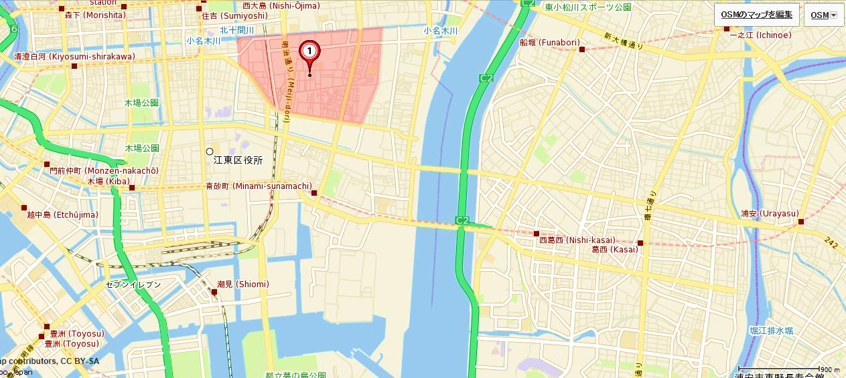
KIST
Start & Goal
Meeting point
The entrance to the riverside
Minami-sunamachi Station
SUNAMO shopping center for parking

Access to the river side from Minamisunamachi Station
Tozai line Tokyo metoro

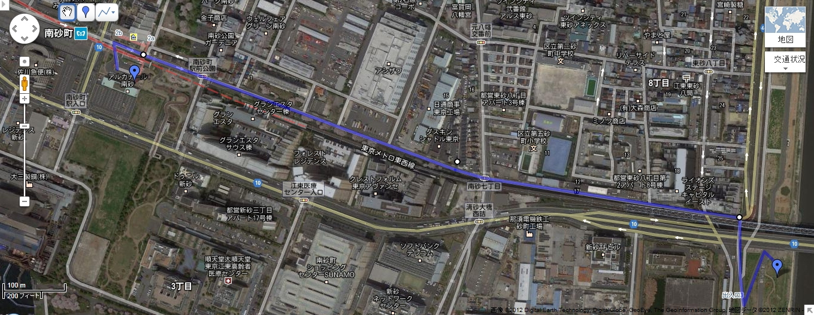
There is entrance to access the river side.
There is balloon mark.
Meeting point
SUNAMO Shopping center
Minamisunamachi Station

The Entrance to the River side

